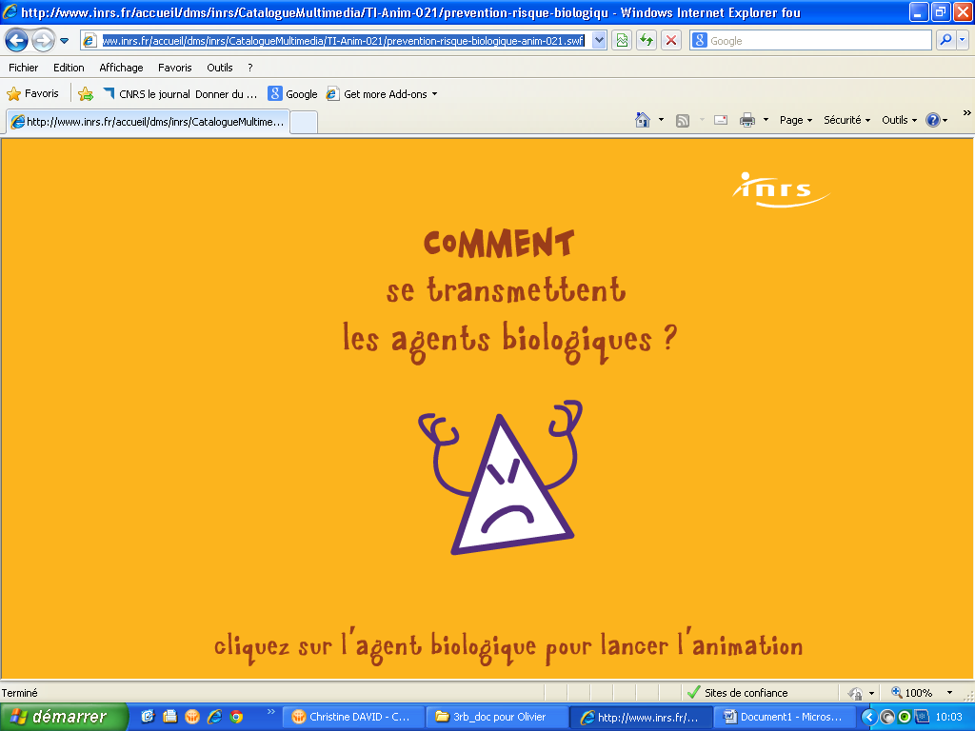

http://www.inrs.fr/accueil/dms/inrs/CatalogueMultimedia/TI-Anim-021/prevention-risque-biologique-anim-021.swf

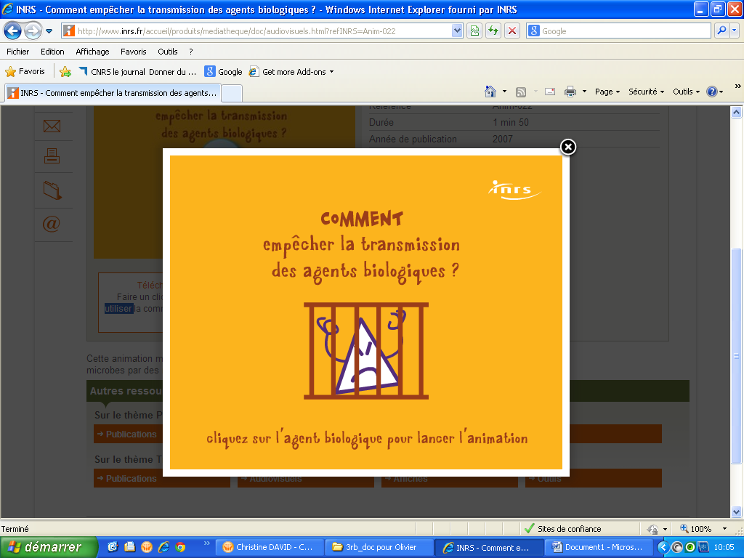

http://www.inrs.fr/accueil/produits/mediatheque/doc/audiovisuels.html?refINRS=Anim-022

http://www.youtube.com/user/INRSFrance
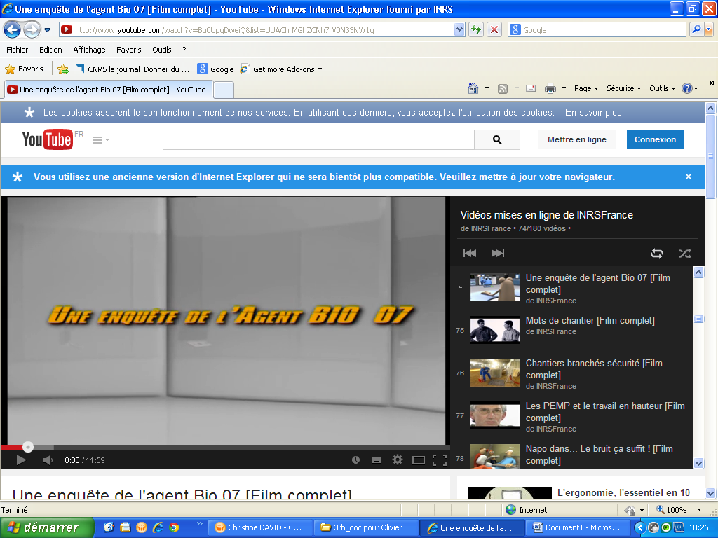

http://www.youtube.com/watch?v=Bu0UpgDweiQ&list=UUAChfMGhZCNh7fV0N33NW1g

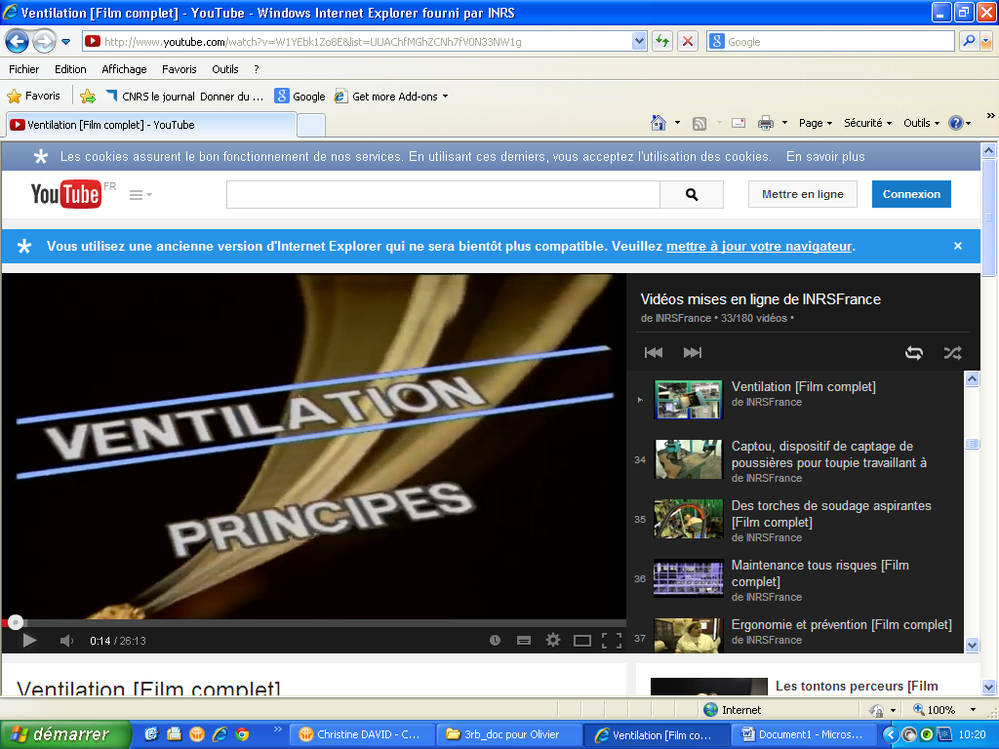

http://www.youtube.com/watch?v=W1YEbk1Zo8E&list=UUAChfMGhZCNh7fV0N33NW1g

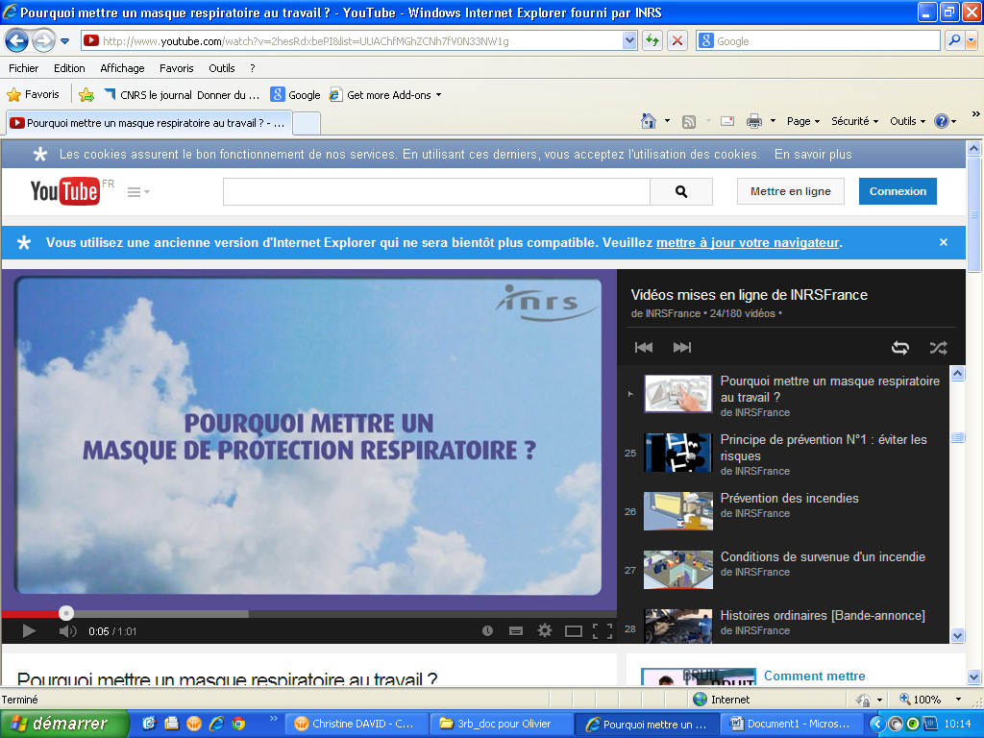

http://www.youtube.com/watch?v=2hesRdxbePI&list=UUAChfMGhZCNh7fV0N33NW1g

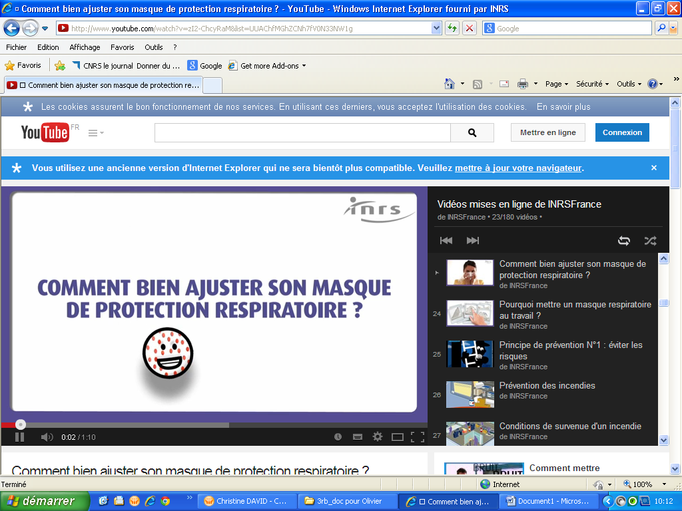

http://www.youtube.com/watch?v=zI2-ChcyRaM&list=UUAChfMGhZCNh7fV0N33NW1g

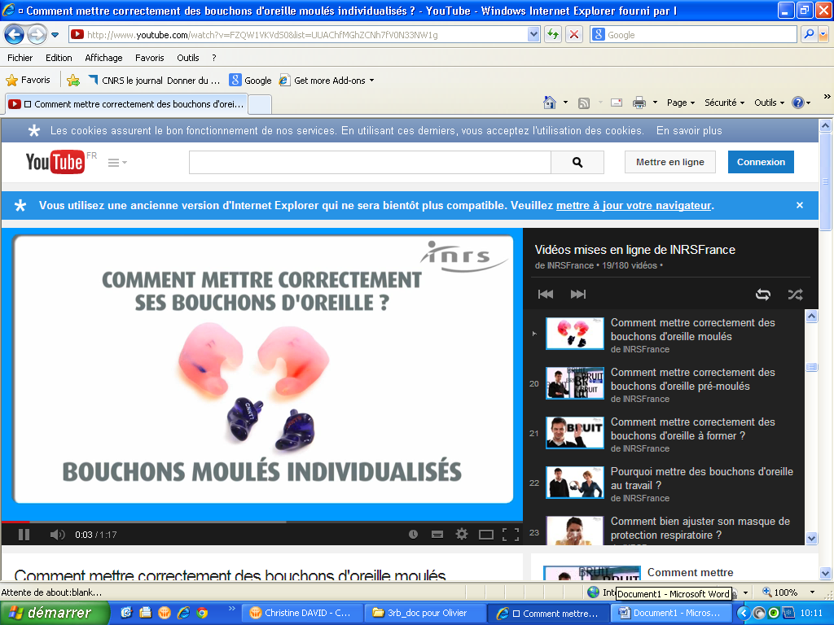

http://www.youtube.com/watch?v=FZQW1VKVdS0&list=UUAChfMGhZCNh7fV0N33NW1g

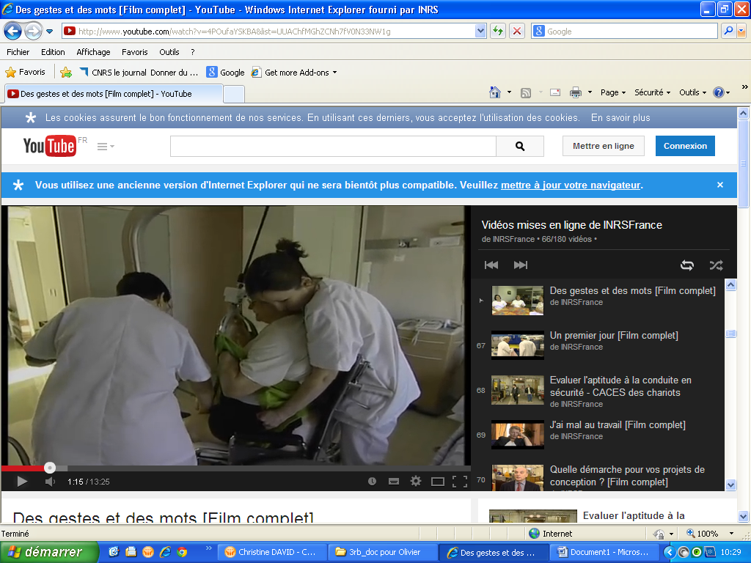
http://www.youtube.com/watch?v=4POufaYSKBA&list=UUAChfMGhZCNh7fV0N33NW1g

